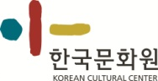
KCC Art Exhibition
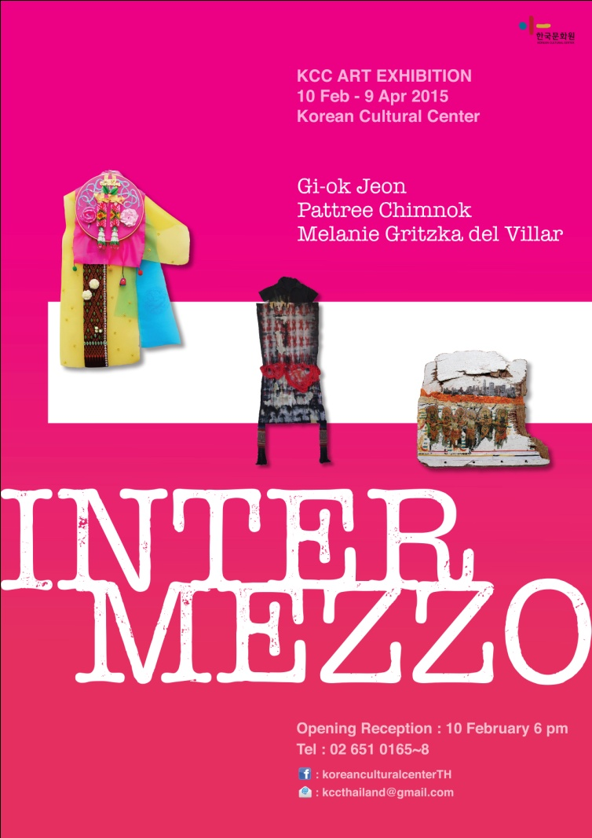
“Intermezzo”
10th February - 9th April 2015
Korean Cultural Center

Artists
Gi-ok Jeon
Melanie Gritzka del Villar
Pattree Chimnok

-------------------------------------------------------------------------------------------
Opening reception : 6 pm
Tel : 02 651 0165~8
E-mail : kccthailand@gmail.com
219/2 Sukhumvit Road, Klongteoy-Nua, Wattana, Bangkok 10110, Thailand
http://thailand.korean-culture.org
https://www.facebook.com/koreanculturalcenterTH
○ Overview
- Title : KCC Art Exhibition “Intermezzo”
- Date : 10th February – 9th April
- Opening Reception Date & Time : 10th February, 6pm (Tue)
- Venue : Korean Cultural Center (Between Sukhumvit Soi 15~17)
- Artists:
o Gi-ok Jeon
o Melanie Gritzka del Villar
o Pattree Chimnok
- Hosted by Korean Cultural Center in Thailand
-Tel : 02 651 0165~8

○ Intermezzo
Three Female Leading Artists Exhibition
The exhibition gives full attention to three female artists from different cultural background; Thai, Korean, and German-Filipina, who reside in Thailand. In order to live within the linked space of cultural differences and to create their own identities, the artists sought the connections and relations between cultures that led to the exhibition’s name ‘Intermezzo’.

Living in multicultural environment can be compared to an ‘Intermezzo’, a performance inserted between the acts of a play preparing for the upcoming climax.

Their wisdom of lives can be also compared with the plants in the mangrove forest. Although they must struggle to find their place among various kinds of plant surrounding them, they are always ready to adjust their roots and live harmoniously with other plants.

Generally, the artists’ works include various kinds of arts such as paintings, sculptures, installations and media-art. This exhibition, they worked together to create new pieces of artwork based on the reality of life.

Artist statement
Gi-ok Jeon
The works display at the Korean Cultural Center, Bangkok are Korean water color paintings and collage works created during 2012 to 2014 and wall installations newly introduced in 2015.
As a migrant, the artist has attempted to find her identity in a different cultural society. Until 2014, her works started to reflect and express her roles as an artist and at the same time as a mother and a housewife. The artist is inspired by her own Thai-Korean daughter who plays an important role in the creation of her artworks. The drawing of her Korean-Thai daughter collaged with traditional Thai fabric ‘Pa-thoong’ shows the linkage between Korean and Thai culture.
Aside from previously mentioned artworks, there is a ceiling-installation of various shaped copper wire baskets. Inside are embodying tree branches wrapped in Pa-thoong fabric. Also a wall-installation of embroidery frames with Hanbok (Korean traditional dress) fabric and other objects are also introduced in this exhibition.

Pattree Chimnok
Human are living in the world, full of diversities in many aspects, which are languages, cultures, traditions, and ways of life. Throughout every ways of communication, Arts is quite an international language which can connect the thoughts and be communicated among the people from all over the world. Moreover, it is also a journal diary which can be written as historical records, expressing through the beauty of the artworks.
My artwork is about the ways of life and the feelings of women towards the societies nowadays, merged with the idea of the traditional cultures, by using simple utilities in their daily life to convey the meaning of the artwork in order to search for the meaning of life through daily life.

Melanie Gritzka del Villar
I consider myself a synthesizer of different cultural references, of archaic as well dream symbols; a reclaimer of discarded or overlooked surfaces. I am interested in a new human ecology, one that respects our interdependence as human beings, our own inner nature, and the natural environment. My main expression is painting, however I frequently use collage and layering techniques too and venture into mixed media work. My art is a record of my experiences, emotions and visions - a record that charts a lived personal reality which hopefully touches upon a more collective and universal truth.
Artists talk on the opening reception day

Gi-ok Kim
Good evening.
Thank you very much for joining the opening tonight.
First of all, I would like to say thanks to all the staffs at the Korean Cultural Center and I’m very happy to be able to make this exhibition together with artist Melanie and Pattree.
Then let me give you a brief introduction of my work.
My work which is featuring at this KCC here was created from year 2011 to 2015.

I’m an emigrant artist. I tried to tell the process of finding my identity in a relationship between Thailand which is different culture and society from Korea, but actually where I belong to and the space where I live currently through my art.

So I tried to connect myself with the Thai society using the image of my mixed-race, I mean a half Thai and a half Korean daughter Lily and carefully cut and collaged patoong in my art. Lily acted for myself as a performer with patoong, firmly connected myself to too different cultures and I also tried to express my multiple roles as an artist, housewife, mother and a woman through Lily and this Thai fabric Patoong.

The installation work both wire sculptures with tree branch and luk yang na which iscollected at a temple, the tall are attached patoong deliver the same meaning like relationship and identity but they concerned deeper into the issue of space and my daily experience. Without space, there would not be artwork and even myself.
Lastly, wall installation of embroidery hoop with Korean traditional fabric called Hanbok and various objects is the new body of work this year. In particular, I’m very pleased to be able to show this work with Korean fabric at KCC for the first time. I attempted to create a new space that is made by an encounter of two different cultures. This new space appears in embroidery hoop that implies a woman’s small space. Sometime, two different cultures seem to be harmonized and some other time, they do not.
Thank you.

Pattree Chimnok
First of all, I would like to thank Korean Cultural Center for the opportunity to display my artworks. And I would like to thank the artists, Gi-ok , and Melanie for all the good time we spent together in learning new cultures and brainstorming some new ideas. And lastly, I would like to thank all of you for being here in this very special occasion tonight.
I was born and raised in Chiangrai, a province in the northern part of Thailand. The place where I’ve been living for all my life is the place where is full of many ethnics, and richness of natural environment.
My life as an artist is like a diary. It’s like a story which has been told through creativity as I tell a story about my experiences, imagination, memories, and random thoughts I have received from people, nature, and local cultures.
In each of my artworks can be compared as a part of time and different states of emotions. They are made by utilities, founded in our daily life, for example, chicken coop, fish creel, clothes, and combined with wax and dyed fabric, in order to create a new meaning for the utilities to be valuable artworks, those can attract the viewers to be curious and question themselves, to exchange their thoughts with the artworks.
Wax is defined as states of emotions, which can be transformed due to the effects of the surrounded environment that I’ve compared with the human’s minds, which can be effected by the reality.
Therefore, my artworks can be seen as a tool of learning, searching for one’s self, and the meaning of life by a vision of an ordinary woman.

Melanie Gritzka del Villar
Good evening, My name is Melanie Gritzka del Villar. I am very happy to see you all gathered here, thank you for coming. I would also like to thank the Korean Cultural Centre for hosting and organizing this exhibition. I feel honoured to show my work alongside that of Gi-ok Jeon and Patter Chimnok. I would also like to thank Gi-ok for inviting me and Patter to take part in this show in the first place. It is beautiful to see how our works interacts and forms a fluid viewing experience. A little bit about myself. I am German-Filipina and have been based in Bangkok since 2006. The work you see from my part represent my exploration of different media. Here on the first floor you can see paintings of earlier years that already show my interest with themes such as indigenous cultures. The driftwood collages mark an important development in my practice. They are the result of being very sensitive to so-called discarded material: the wood, the cut-outs from newspapers. Making them I was able to rediscover the joy of finding beauty in the mundane and often overlooked surfaces and imagery. They are fragments or tablets that show an identity adrift amongst our mutli-cultural world. But they also talk about simple joys in life, the relationship humans have with the ocean, they talk about climate change and how it affects us all, they talk about childhood and community. On the second floor you will find more recent work of mine. 4 paintings that are an exploration of my inner life, and the processing of life experiences: love and heartbreak, being overhwhelmed by emotions and external events, doubt and confusion, but also the state of temporary serenity. The driftwood paintings on the second floor form part of my most recent work. In a way, they are a synthesis of the driftwood collages and the paintings. Here I am painting in the surreal-realistic comic style of my most recent paintings but on the same kind of surface I have used for the driftwood collages. What I am exploring now is a wider context of the human condition in relation with the natural environment, the planet, our home. I am trying to translate personal experiences and visions into a language that is almost mythical in character. Looking at these pieces one might be transported back into childhood and remember certain stills from fairytales. My intention though is not to depict moments of a fairytale per se, no; what I am trying to do is to create a visual language and imagery of what I believe a lot of us are unconsciously craving for: a visual language that acts as a portal into a deeper experience of connectedness, imagination and hope. Thank you and I hope you enjoy the show and evening.

○ รายละเอียดงาน
- ชื่องาน : นิทรรศการแสดงศิลปะ “Intermezzo”
- วันที่ : 10 กุมภาพันธ์ – 9 เมษายน 2558
- วัน/เวลา เปิดงานนิทรรศการ : วันอังคารที่ 10 กุมภาพันธ์ 2558 เวลา 18.00 น.
- สถานที่ : ศูนย์วัฒนธรรมเกาหลีประจำประเทศไทย ( ระหว่างสุขุมวิทซอย 15 – 17 )
- ศิลปิน :
o Gi-ok Jeon
o Melanie Gritzka del Villar
o Pattree Chimnok
- จัดแสดงโดยศูนย์วัฒนธรรมเกาหลี ประจำประเทศไทย
- โทร : 02-6510165-8

○ Intermezzo

นิทรรศการนี้เน้นให้ความสำคัญกับศิลปินหญิงจากสามเชื้อชาติ ได้แก่ ไทย เกาหลีและเยอรมัน-ฟิลิปปินส์ ปัจจุบันทั้งสามทำงานและพำนักอยู่ในประเทศไทย ศิลปินทั้งสามได้พยายามหาจุดเชื่อมต่อ เพื่อเติมเต็มช่องว่างของความแตกต่างทางวัฒนธรรม และหาอัตลักษณ์ของตนเอง ซึ่งเป็นที่มาของชื่อนิทรรศการ ‘Intermezzo'
การที่จะดำเนินชีวิตในสังคมที่แตกต่าง อาจเปรียบได้กับการแสดงหรือดนตรีบรรเลงสลับฉากหรือที่เรียกว่า ‘Intermezzo’ คือเป็นการเตรียมความพร้อมเข้าสู่ส่วนสำคัญสูงสุดของการแสดงนั้นเอง
วิถีชีวิตของศิลปินทั้งสามก็เปรียบได้กับพรรณไม้ในป่าชายเลน ซึ่งพร้อมจะปรับตัวให้เข้ากับสภาพแวดล้อมและสามารถอยู่ร่วมกับพรรณไม้ชนิดอื่นได้อย่างสงบสุข
โดยปกติศิลปินทั้งสามท่านมีผลงานศิลปะในแขนงต่างๆ เช่น จิตรกรรม ประติมากรรม สื่อและการจัดแสดงศิลปะจัดวาง แต่ในครั้งนี้ได้ร่วมกันสร้างสรรค์ผลงานแนวใหม่โดยอ้างอิงจากโลกความเป็นจริง

ถ้อยแถลงศิลปิน
Gi-ok Jeon
ผลงานที่จัดแสดง ณ ศูนย์วัฒนธรรมเกาหลี ประจำประเทศไทย ประกอบด้วยผลงานภาพสีน้ำแบบเกาหลีและภาพปะติดซึ่งสร้างสรรค์ขึ้นในช่วงปี 2012 – 2014 และการจัดแสดงผลงานศิลปะจัดวางซึ่งเป็นผลงานใหม่ของปี 2015
ในฐานะชาวต่างชาติที่ย้ายถิ่นฐานมาพำนักอยู่ในประเทศไทย ศิลปินได้พยายามค้นหาอัตลักษณ์ของตนเองจนกระทั่งปี 2014 เกิดการสะท้อนผลงานผ่านทางบทบาทของความเป็นแม่บ้าน แม่และศิลปินหญิง โดยมีบุตรสาวเป็นแรงบันดาลใจในการสร้างสรรค์ผลงาน เนื่องจากศิลปินสมรสกับชาวไทย บุตรสาวจึงเป็นตัวละครสำคัญในการสร้างสรรค์ผลงาน และเป็นตัวเชื่อมระหว่างสองวัฒนธรรมเข้าด้วยกัน
นอกจากผลงานภาพปะติดแล้ว ผลงานอื่นที่นำมาจัดแสดงครั้งนี้ ได้แก่ ศิลปะจัดวางโดยการนำกิ่งไม้พันด้วยผ้าถุงจัดวางในตะกร้าสานลวดทองแดง และผลงานที่เกิดจากการนำผ้าฮันบกและวัสดุชนิดอื่นๆ มาประดับรวมกันโดยใช้เทคนิคที่หลากหลาย

Pattree Chimnok

มนุษย์มีความหลากหลายของภาษา วิถีและวัฒนธรรมประเพณี แต่ศิลปะกลับเป็นดั่งภาษาสากล ที่เชื่อมโยงและแลกเปลี่ยนสื่อสาสน์ซึ่งกันและกันของผู้คน เปรียบเสมือนเครื่องมือที่สะท้อนเรื่องราวรอบๆ ตัวและบันทึกแห่งกาลเวลา ที่มีต่อการเรียนรู้ความหมายแห่งการดำรงอยู่
ผลงานศิลปะของข้าพเจ้าเผยให้เห็นถึงวิถีความเป็นอยู่ และสภาวะอารมณ์ของผู้หญิงต่อสถานการณ์และสภาพสังคมปัจจุบัน ภายใต้กรอบความคิดทางวัฒนธรรมและประเพณี โดยสื่อผ่านเรื่องราวด้วยข้าวของเครื่องใช้ทั่วๆ ไปที่ใช้ในชีวิตประจำวันอย่างสามัญธรรมดา เพื่อค้นหาความหมายของชีวิต โดยผ่านการใช้ชีวิต

Melanie Gritzka del Villar
ในฐานะศิลปิน ข้าพเจ้าสามารถเปรียบตนเองได้ดั่งผู้ที่สามารถสังเคราะห์ลักษณะของวัฒนธรรม ที่มีความแตกต่างและมีความเก่าแก่ อีกทั้งยังเป็นผู้ที่ให้ความสำคัญกับลักษณะภายนอกของสรรพสิ่งต่างๆ ที่มักถูกคนส่วนใหญ่มองข้ามและละเลย ข้าพเจ้ามีความสนใจในธรรมชาติของมนุษย์ เพราะมนุษย์เป็นสิ่งมีชีวิตที่มีการพึ่งพาอาศัยกัน ทั้งกับมนุษย์ด้วยกันเองและสภาพแวดล้อมรอบตัว โดยส่วนใหญ่ข้าพเจ้าได้สื่อความหมายต่างๆ เหล่านั้นผ่านการวาดรูป และในบางครั้งก็ได้ใช้วิธีการอื่นๆ เช่น การตัดต่อภาพ และการใช้วิธีเรเยอริ่งผสมลงไปในผลงานต่างๆ ของข้าพเจ้า ผลงานของข้าพเจ้าเป็นเหมือน
บันทึกที่เต็มไปด้วยประสบการณ์ อารมณ์ และวิสัยทัศน์ที่เป็นความจริงสิ่งหนึ่งของบุคคล ที่แสดงออกผ่านผลงานโดยมีความคาดหวังให้กลายเป็นความจริงที่เป็นสากลมากขึ้น
○ 개요
- 행사명 : 한태미술교류전 “인터메조”
- 일시 : 2015년 2월 10일(수) – 4월 9일
- 오프닝 리셉션 : 2015년 2월 10일 오후 6시
- 장소 : 한국문화원 (수쿰윗 15~17 사이)
- 아티스트 :
o 전기옥
o 멜라니 그리즈카 델 빌라
o 파트리 침넉
- 주최 :주태국 한국문화원
- 문의 및 등록 :Tel : 02 651 0165~8

○ 인터메조

중견 여성작가 3인전

이번 전시는 중견 여성작가 3인에 주목한다. 한국, 태국 그리고 독일/필리핀을 국적으로 가지고 태국에서 활동하는 작가들이다. 이질적인 경계 사이에서 유동하는 이들은 이문화를 연결시키는 공간 속에서 필연적인 존재의 이유를 찾아가며 삶을 적극적으로 응시한다.

막간에 다음의 클라이막스를 준비하는 간주곡(인터메조)처럼, 사물의 틈 존재의 사이에서 한번 멈춰가는 삶의 지혜. 복잡하게 얽힌 뿌리조직과 그 환경에 적응된 타종의 나무들이 함께 어우러져 조수의 리듬에 맞춰 서식하는 맹그로브 숲처럼, 이들의 생명력은 부드럽고 풍성하다.

페인팅, 조각, 설치, 영상 등 다양한 작업을 통해, 일상의 현실을 배척하지 않고 자유롭게 접속하며, 이전과는 다른 접속을 실험하는 유쾌한 시선이 담겨 있다.

작업 소개

전기옥 (Gi-ok Jeon)
이번 전시는 2012년부터 2014년까지 작업했던 한국 전통 수채화와 꼴라주 한 작품들과, 2015년에 작업한 벽면 설치작품으로 구성했다. 이주민으로서 나는, 다른 문화 속에서 나의 정체성을 찾아가는 작업을 해왔다. 2014년에는 미술가로서 그리고 동시에 엄마와 아내로서의 역할이 투영된 작업을 했다. 한국과 태국을 반씩 담은 딸은 작업에 많은 영감을 주었다. 딸과 태국 전통 옷감인 “파퉁(Pa-toong)”을 꼴라주 한 드로잉 작업은 한국과 태국 문화를 연결해주는 매개체이다. 또 다른 작업으로, 다양한 모양의 구리선 바구니를 천장에 설치한다. 바구니 안에는 파퉁 천으로 감싼 나뭇가지가 들어 있다. 한복 천과 다른 오브제로 프레임을 만든 벽 설치작업도 이번 전시에 소개할 예정이다.

빠뜨리 침녹 (Pattree Chimnok)
사람들은 언어, 문화, 전통, 그리고 삶의 방식 등 다양한 맥락 속에서 다양한 방식으로 살아가고 있다. 소통의 여러 가지 방식 중에서도, 예술은 세상과 더불어 생각을 연결하고 소통할 수 있는 매우 범세계적인 언어이다. 나아가, 작업물의 아름다움을 표현하는 역사적인 기록물로서의 일기이기도 하다. 나의 작업은 전통적인 문화의 사고 속에 융합된, 요즘의 사회를 바라보는 여성의 삶의 방식과 감정에 대해 이야기한다. 일상에서 볼 수 있는 단순한 물품들을 사용해, 일상생활을 통해 삶의 의미를 탐색하기 위한 예술작업들을 보여주고자 한다.

멜라니 그리츠카 델 빌라 (Melanie Gritzka del Villar)
나는 나 자신이, 폐기되거나 간과된 수면의 반환 요구자로서 꿈의 상징만큼이나 낡은, 다른 문화적 레퍼런스의 합성기라고 생각된다. 나는 인간으로서 상호의존과 자기 안의 본능, 그리고 자연환경을 존중하는 새로운 인간 생태에 관심이 많다. 주로 회화 작업을 하지만, 종종 믹스미디어 작업을 통해 꼴라주와 레이어링 기법을 사용해 작업하기도 한다. 나의 작업은 나의 경험과 감정, 비전의 기록으로서, 보다 집합적이고 보편적인 진실을 건드릴 수 있는 살아있는 개인의 현실을 담는다.

