Press release

Gyproc showcases perfect home innovations under concept “Smart Life Beyond” at Ban Lae Suan Fair 2015
31 October – 8 November 2015,
1-3 IMPACT Challenger Hall booth J70-73, J96-99, Muang Thong Thani
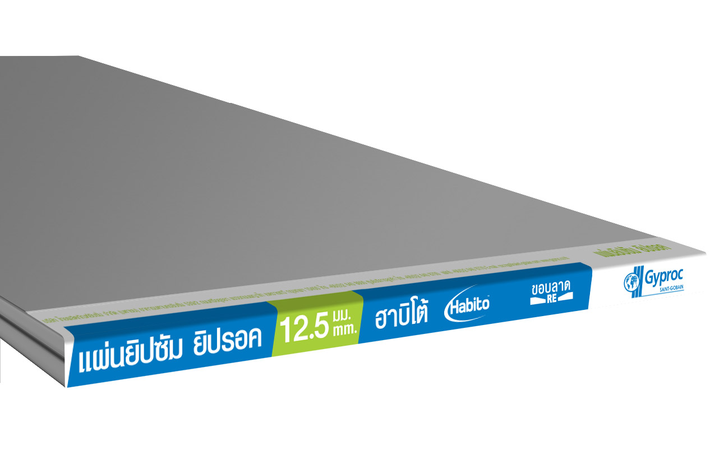  Gyproc® HabitoTM gypsum board | 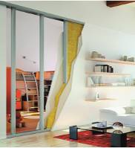  Gyproc® HabitoTM gypsum board
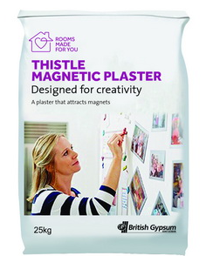  Gyproc® Magnetic Plaster |   Picture of Gyproc® Magnetic Plaster changes normal walls into brilliantly revolutionary magnetic plates

Bangkok - Thai Gypsum Products Public Company Limited, the manufacturer of gypsum innovations for 45 years and of the leading brand “Gyproc,” joins Ban Lae Suan Fair 2015 at Challenger Hall 1-3 IMPACT Muang Thong Thani, to showcase its latest innovative materials and construction systems under the concept, “Smart Life Beyond.” Gyproc’s exhibition presents comprehensive home solutions for ceilings, walls and finishing that are safe for consumers, easy to install and eco-friendly. During the event Gyproc will launch two new products for the first time in Asia gypsum industry: Gyproc® HabitoTM an innovative wall solution designed to allow homeowners to style their living space in a fast and functional way, and Gyproc® Magnetic Plaster, a newly-formulated plaster that transforms normal walls into magnetic areas and also covers cracks effectively. These two new products are offered in 4 Gyproc Centers; Builder smart Public Co., Ltd (Rama 3 road), 3D mat Co., Ltd. (Phutthamonthon Sai 2), Chokchai 2 Glass Co., Ltd. (Pattaya) and Phuket Kasem Co., Ltd. (Phuket) that will be available nationwide by the first quarter of 2016.

Gyproc® HabitoTM offers a new choice of construction for homeowners who want to have better well-being. It combines three ideal qualities that are Extreme Shock-Resistance, Soundproof, and Easy to Install. With the new patented technology used to develop the Gyproc® HabitoTM boards, objects weighing up to 15kg can be hung from a simple chipboard screw with a diameter of 10 mm. Due to their solid core, Habito boards are up to five times stronger than regular boards, easy fixing and are more resistant to repeated impacts.

Another innovative product launched at the event is Gyproc® Magnetic Plaster. With a smooth texture and easy-to-use quality, the product can be applied on many types of surface such as Gyproc cement, ProCoat, normal plaster, concrete walls or gypsum boards. It is suited to an interior coating that has 3-7 mm. of thickness, so it can cover all cracks perfectly. Importantly, Gyproc® Magnetic Plaster changes normal walls into brilliantly revolutionary magnetic plates. By using this product, owners can decorate their living space as their imagination runs free, or turn their walls to an interactive area for sharing opinions. For professional group, we can use this wall in office to present the ideas in a professional way.

Richard Juggery, Managing Director, Thai Gypsum Products Public Company Limited, said, “The launch of these two products is part of our business plan to position Gyproc as a leader of the interior décor industry in Thailand. We offer innovative products and solutions that cover all types of properties like houses, condominiums, offices, schools, hotels, hospitals, restaurants and so forth. To meet all demands of the consumer’s lifestyle, inspire their décor imagination, or support business work with no limits.”

Gyproc’s solutions are ideal for creating the perfect home environment, including options for home theater room creation, as well as Gyproc’s established bedroom, kitchen and bathroom solutions. In addition, visitors can receive creative consulting from a team of highly skilled experts to provide detailed advice throughout Ban Lae Suan Fair 2015. In addition to the Gyproc room “mock-up” display, visitors can also enjoy an exhibition of Saint-Gobain’s 350 Year Anniversary; it presents the group’s history of designing, manufacturing and distributing building materials and high performance solutions for customers and sustainable habitats around the globe.

For more information, please contact 02-640-8600, or visit website http://www.gyproc.co.th/ https://www.saint-gobain.com/en/350-years and Facebook https://www.facebook.com/GyprocClub

###

About Thai Gypsum Products Plc.
Thai Gypsum Products Pcl., was established in 1968, and is Thailand’s pioneering manufacturer of quality gypsum plasterboards and plasters. Its products and solutions are currently well-known and well-regarded in the construction industry in Thailand and Asia Pacific. Thai Gypsum Products owns two modern gypsum plants, at Laem Chabang, Chonburi and Bang Pa-In, Ayutthaya. Thai Gypsum offers a complete range of gypsum plasterboard, gypsum ceiling tile, metal system components and powder finishing products, as well as innovative solutions focusing on offering a complete interior for its customers.

Recognizing the importance of environmental conservation, the company’s operations adhere to its Gyproc Go Green (3G) philosophy. Green Products include Gyproc plasterboards and ceiling systems which are ASTM D5116-90 compliant; the level of dispersion/evaporation of chemicals from Gyproc products does not exceed required standards, and the use of eco-friendly, recycled materials is not less than 30%. Products are free from radioactive agents and health-threatening elements such as cadmium and lead. Green Solutions includes full wall and ceiling energy-saving solutions to prevent heat transmission into the building from outside, reducing the load on air conditioning and reducing Co2 emissions. Gyproc’s Green Manufacturing process is environmentally compassionate, including the installation of wastewater treatment technology and energy-efficient systems with ISO 14001 certification and Green Label certification.

About Saint-Gobain Group
Thai Gypsum Products Pcl. is part of Saint-Gobain Group, the world's largest building products manufacturer. Saint-Gobain Group specializes in the design, production and distribution of functional and sustainable materials for construction, industrial and consumer markets. The Company invests in research and development continuously to offer high quality products at very reasonable prices. Consumers benefit from high performance solutions that are hypo-allergenic, antibacterial, comfortable in use and have a long service life, whilst installers enjoy fast, easy installation.

Saint-Gobain and its 180,000 employees are organized into four business sectors: Flat Glass, Packaging, Construction Products and Building Materials Distribution. Thai Gypsum is part of Saint-Gobain’s world-leading Gypsum activity, and Gypsum boards have gained strong market recognition in over 40 countries throughout the Asia Pacific Region. Gyproc is manufactured under strictly monitored processes certified to ISO 9001:2008 and ISO 14001:2004, and is compliant with many well accepted international standards.

For further information, please contact Vivaldi Public Relations, Tel: +66 (0) 2 612 2253 Ext.103, Fax: +66 (0) 2612 2254; Website: www.vivaldipr.com
Veerawan Saejao Tanyaporn Kanchanahoti
Senior PR Executive Senior PR Executive
T: +66 (0) 85 000 1476 T: +66 (0) 84 448 3067
Email: veerawan.s@vivaldipr.com Email: tanyaporn.k@vivaldipr.com

